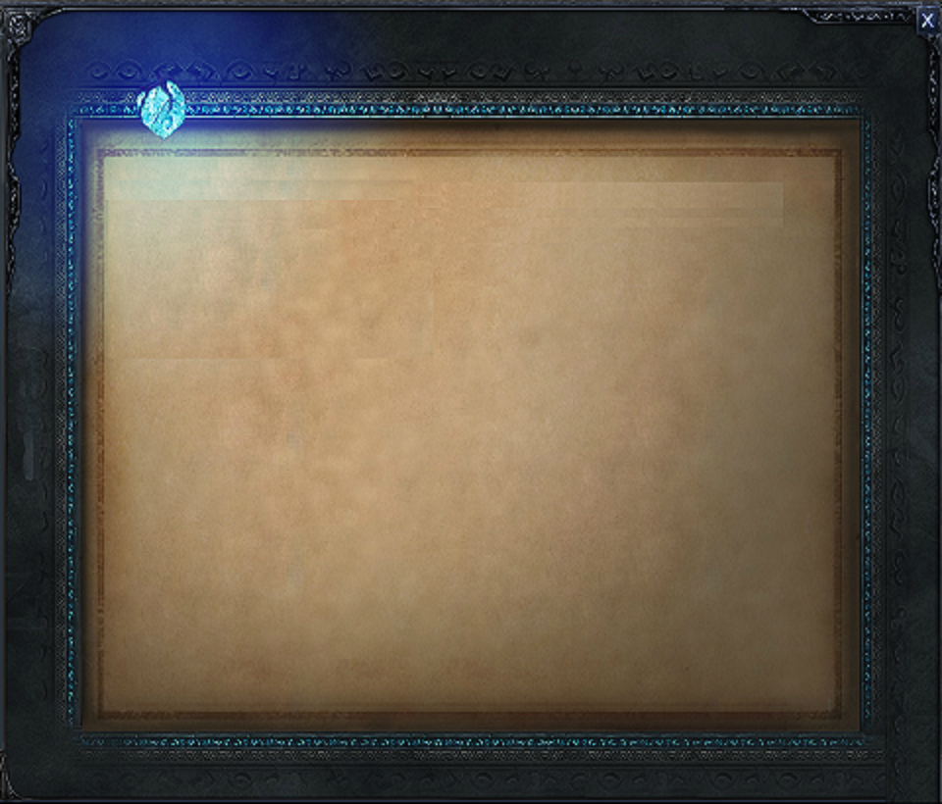

Kong left, journeying north, determined to discover if the legend was true. He crossed the Sothern Wastes and then the Great Barrier. On his way, he happened upon Master Yi, who was in deep meditation. Kong asked him who the strongest warrior in the north was, and Yi told him about the League of Legends. The tale intoxicate Kong, a place where he could battle the strongest fighters in the world was, to him, paradise. Kong asked Yi to introduce him to this League, and to teach him the ways of humans, so that he could be a fitting champion. In return, he would honour Yi by using Yi’s Wuju style to become the greatest warrior Runeterra had ever seen. Admiring his passion, Yi agreed, but under the condition that Kong would one day teach the lessons of Wuju to a pupil of his own. In the spirit of this agreement, he renamed Kong *Wukong*, and gave him a weapon suited to his unusual nature - an enchanted staff that the young Doran had crafted. The weapon was an unrivalled masterpiece. Guided by Yi, Wukong join the League of Legends to prove himself as the best, and to show the world the true power of Wuju.